Volatility correlation: NZDUSD and USDJPY
Method 25 / daily |log returns| / rho_vol / Alpari D1 full available history (realized deferred)

Study setup
Logical pair: NZDUSD , USDJPY
Broker symbols: NZDUSD_i , USDJPY_i
Snapshot: 2026-11-03_majors_alpari_D1
Timeframe: D1
Matched return window: 1999-01-05 to 2026-11-02 (UTC bar dates)
Matched return count n: 7185
Dropped unfinished last bar dated 2026-11-03 UTC after a tick-volume check against the prior complete day.
Statistic: rho_vol = Corr(|log return_L|, |log return_R|)
rho_realized: not computed (no intraday buckets in this snapshot)
Complete matched rows (Excel): NZDUSD-USDJPY_Vol_D1.xlsx
Complete matched rows (HTML table): NZDUSD-USDJPY_Vol_D1_data.html

Method carried forward
Volatility correlation rho_vol = Corr(|x_t|, |y_t|) measures whether absolute daily log returns of close move together in size, regardless of sign. Quotes are not inverted. Same-sample signed Pearson r is a side check. The formula sheet also defines within-day realized correlation rho_realized,d from intraday buckets; this v001 uses the Alpari D1 snapshot only, so rho_realized is not computed (no intraday buckets). This is not causation and not a trading signal.

Results (headline)
rho_vol: 0.304709
Pearson r (signed): -0.133568
mean |NZDUSD|: 0.00566842
mean |USDJPY|: 0.00444515
rho_realized: n/a (D1-only snapshot)

Conclusion
Headline rho_vol for NZDUSD and USDJPY: 0.3047. Signed Pearson r = -0.1336. Mean |return|: 0.005668 (NZDUSD), 0.004445 (USDJPY). rho_realized not computed (D1 snapshot has no intraday buckets). This is absolute-move co-movement, not a trading signal.

Charts
Daily closes

Daily log returns

Absolute returns scatter
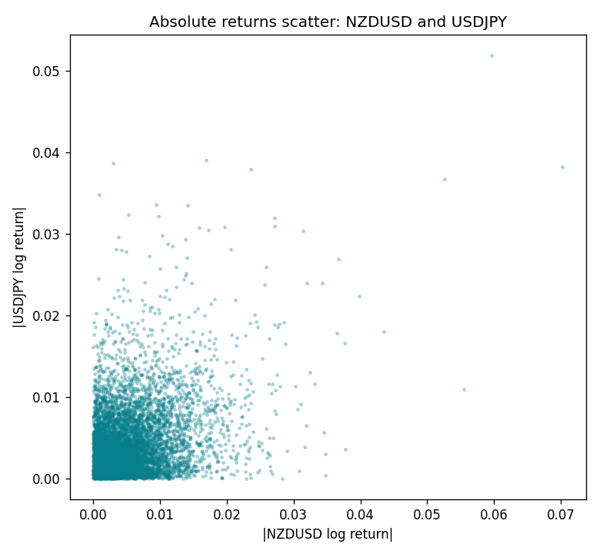

Data report
Matched rows are in the sibling Excel workbook named NZDUSD-USDJPY_Vol_D1.xlsx. Embedding all rows as a Word table is impractical; this file holds column summaries and the first and last 15 matched rows.
Columns: time, NZDUSD_open, USDJPY_open, NZDUSD_high, USDJPY_high, NZDUSD_low, USDJPY_low, NZDUSD_close, USDJPY_close, NZDUSD_tick_volume, USDJPY_tick_volume, NZDUSD_spread, USDJPY_spread, NZDUSD_real_volume, USDJPY_real_volume, NZDUSD_log_return, USDJPY_log_return, NZDUSD_abs_return, USDJPY_abs_return
Column summaries (matched calculation rows)
column | count | mean | std | min | 25% | 50% | 75% | max
NZDUSD_open | 7185 | 0.65641035 | 0.10820414 | 0.3913 | 0.59133 | 0.6684 | 0.72491 | 0.88218
USDJPY_open | 7185 | 113.80829 | 19.224285 | 75.693 | 104.39 | 110.98 | 120.695 | 163.824
NZDUSD_high | 7185 | 0.6603272 | 0.1086977 | 0.3961 | 0.59474 | 0.672 | 0.72936 | 0.88421
USDJPY_high | 7185 | 114.30556 | 19.28576 | 76.001 | 104.868 | 111.439 | 121.26 | 163.978
NZDUSD_low | 7185 | 0.65272421 | 0.10779902 | 0.3897 | 0.58806 | 0.66417 | 0.72098 | 0.87988
USDJPY_low | 7185 | 113.28523 | 19.152023 | 75.402 | 103.88 | 110.53 | 120.17 | 163.628
NZDUSD_close | 7185 | 0.65648647 | 0.10820164 | 0.3907 | 0.59157 | 0.6684 | 0.72502 | 0.8822
USDJPY_close | 7185 | 113.8211 | 19.239467 | 75.811 | 104.38 | 111.015 | 120.69 | 163.851
NZDUSD_tick_volume | 7185 | 68717.699 | 123140.61 | 16 | 5585 | 33899 | 58511 | 1127682
USDJPY_tick_volume | 7185 | 106344.18 | 179438.14 | 149 | 9948 | 53202 | 92889 | 1803508
NZDUSD_spread | 7185 | 30.280167 | 25.649381 | 0 | 9 | 17 | 40 | 80
USDJPY_spread | 7185 | 20.273626 | 17.623751 | 0 | 6 | 11 | 30 | 50
NZDUSD_real_volume | 7185 | 1.6703703e+10 | 8.4983725e+10 | 0 | 0 | 0 | 0 | 2.705649e+12
USDJPY_real_volume | 7185 | 3.4781051e+10 | 1.6093614e+11 | 0 | 0 | 0 | 0 | 3.8834203e+12
NZDUSD_log_return | 7185 | 1.284e-05 | 0.0076404 | -0.07027433 | -0.00425236 | 0.00022967 | 0.00458145 | 0.05966839
USDJPY_log_return | 7185 | 4.789e-05 | 0.00620418 | -0.03908203 | -0.00320044 | 0.00011802 | 0.00340223 | 0.05184024
NZDUSD_abs_return | 7185 | 0.00566842 | 0.00512254 | 0 | 0.00203903 | 0.00443777 | 0.0077735 | 0.07027433
USDJPY_abs_return | 7185 | 0.00444515 | 0.00432805 | 0 | 0.00143099 | 0.00330308 | 0.00618732 | 0.05184024
First 15 matched rows (selected columns)
time | NZDUSD_log_return | USDJPY_log_return | NZDUSD_abs_return | USDJPY_abs_return
1999-01-05 | -0.0018597736 | -0.00017868311 | 0.0018597736 | 0.00017868311
1999-01-06 | 0.0020455609 | 0.0075660159 | 0.0020455609 | 0.0075660159
1999-01-07 | 0.0062963171 | -0.012851583 | 0.0062963171 | 0.012851583
1999-01-08 | -0.00055396548 | -0.0047719894 | 0.00055396548 | 0.0047719894
1999-01-11 | 0.010290425 | -0.016195423 | 0.010290425 | 0.016195423
1999-01-12 | -0.0053157489 | 0.032310364 | 0.0053157489 | 0.032310364
1999-01-13 | -0.0099742238 | 0.0081373171 | 0.0099742238 | 0.0081373171
1999-01-14 | -0.00018564931 | 0 | 0.00018564931 | 0
1999-01-15 | -0.00074294208 | 0.0055343401 | 0.00074294208 | 0.0055343401
1999-01-18 | -0.0018597736 | 8.7600193e-05 | 0.0018597736 | 8.7600193e-05
1999-01-19 | 0.0018597736 | -0.0056219403 | 0.0018597736 | 0.0056219403
1999-01-20 | 0.0040793678 | -0.0053879917 | 0.0040793678 | 0.0053879917
1999-01-21 | 0.0040627941 | 0.0084664056 | 0.0040627941 | 0.0084664056
1999-01-22 | -0.012051689 | 0.0060412564 | 0.012051689 | 0.0060412564
1999-01-25 | -0.0035504102 | -0.0073594164 | 0.0035504102 | 0.0073594164
Last 15 matched rows (selected columns)
time | NZDUSD_log_return | USDJPY_log_return | NZDUSD_abs_return | USDJPY_abs_return
2026-10-13 | 0.0047326165 | -0.0018932826 | 0.0047326165 | 0.0018932826
2026-10-14 | -0.0037306483 | 7.5800166e-05 | 0.0037306483 | 7.5800166e-05
2026-10-15 | 0.0047634855 | -0.0018524319 | 0.0047634855 | 0.0018524319
2026-10-16 | 0.0057501001 | -0.00037976126 | 0.0057501001 | 0.00037976126
2026-10-19 | 0.0018917133 | 0.0034946841 | 0.0018917133 | 0.0034946841
2026-10-20 | 0.0037199341 | -0.0022546642 | 0.0037199341 | 0.0022546642
2026-10-21 | 0.0030923331 | -0.00032883504 | 0.0030923331 | 0.00032883504
2026-10-22 | -0.0033035227 | -0.0085942669 | 0.0033035227 | 0.0085942669
2026-10-23 | 0.0030929853 | 0.00035080446 | 0.0030929853 | 0.00035080446
2026-10-26 | -0.0028993932 | 0.0041238746 | 0.0028993932 | 0.0041238746
2026-10-27 | -0.00026399852 | 0.0027651658 | 0.00026399852 | 0.0027651658
2026-10-28 | -0.0097283914 | -0.00095679538 | 0.0097283914 | 0.00095679538
2026-10-29 | 0.00062190714 | -0.00038043789 | 0.00062190714 | 0.00038043789
2026-10-30 | 0.00019537668 | -0.0010596481 | 0.00019537668 | 0.0010596481
2026-11-02 | -0.0025962955 | 0.0026438521 | 0.0025962955 | 0.0026438521

